# Section 2 – Introduction to CAPITA

**Date last modified: 20 August 2021**

## Introduction

CAPITA[1] is a general-purpose static microsimulation model of Australia’s personal income tax-transfer system designed to analyse the distributional impacts of policy across the Australian population and highlight interactions between the tax and transfer systems. It consists of a representative sample of the population and a set of rules for calculating the taxes and transfers applicable to each individual. These rules can be varied to examine the effects of changes to personal income tax and transfer policies on individuals, families and groups within the population.

CAPITA was developed to replace STINMOD as the Commonwealth’s distributional model of the Australian personal income tax and transfer system. It has the same broad functionality as STINMOD but has been reviewed and restructured to reduce maintenance costs and shorten training times for new users.

This section provides an introduction to CAPITA, including a brief explanation of microsimulation modelling, the policies which are included in CAPITA, and a description of the main ways in which CAPITA can be used.

## Microsimulation Models

CAPITA is a static microsimulation model of Australia’s personal income tax and transfer system.

Microsimulation models carry out calculations on a collection of individual records. They allow outcomes at the individual level to be aggregated to shed light on policy impacts for particular groups, or the whole population. They are especially useful for analysing the effects of policy where policies interact with each other and a diverse range of outcomes are experienced by individuals in differing circumstances.

CAPITA contains a set of rules for calculating the taxes and transfers applicable to each individual. These can be altered to examine the effects of changes to personal income tax and transfer policies on individuals, households, groups of households or at a national level.

## Static Models

Static microsimulation models take a snapshot of the population at a particular point in time and simulate short run (or ‘morning after’) impacts of changes in policy. This snapshot contains detailed information on income, age and family characteristics and often only covers a sample of the population. For analysis, observations in the sample are scaled by a ‘weight’ that reflects how much of the total population a particular observation represents. To model the effect of policy changes in future years, the characteristics of the individual units are held constant over time and the original snapshot is ‘aged’[2]. This ageing process involves adjusting the weights of the individual units, so that the population matches broad demographic trends, and inflating economic data, such as incomes, using an appropriate inflator. To model the impact of policy change, outcomes under the current system are calculated and compared with outcomes under an alternative system.

## Design Principles

CAPITA has been designed in accordance with the following principles:

* The code has been kept **simple**, while still capturing the important aspects of the tax and transfer system.
* The code is **transparent**, with a clearly defined structure, and adheres to **coding protocols**.
* The model is well documented to ensure it is **easy to update for changes to policies or underlying data sources.**
* The model contains the **functionality** to model the important aspects of the personal tax and transfer system. Note that an appropriate balance is required between ensuring the model contains all the required functionality while also ensuring it remains simple and transparent.

## Structure of CAPITA

There are two main structural components of CAPITA – the basefiles and the policy modules. The model can be conceptualised as follows:

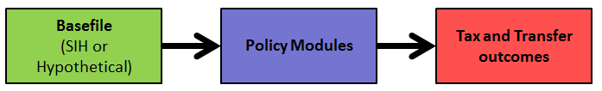

**Figure 2.1: Structure of CAPITA**

### *CAPITA Basefiles*

The distributional CAPITA basefile is based on the Australian Bureau of Statistics’ Survey of Income and Housing (SIH) which collects detailed demographic and income information from a sample of households. In 2017-18, 14,060 households were surveyed representing 97 per cent of the population. Each household is assigned a weight to indicate the number of households it represents to ensure the survey data is representative of the population of interest.

The SIH collects information from individuals and households and outputs this information at multiple levels - including person, income unit and household. A household consists of people living in one dwelling whereas an income unit is a person or group of people within a household who share income. There may be several income units in one household. A single person, a couple, a single person with dependent children, or a couple with dependent children are all examples of income units. CAPITA is based on income units because it best aligns with the testing of transfer payments but it can also perform analysis at the individual and household level.

To ensure the survey data remains representative over the years in which the model runs, CAPITA makes adjustments referred to as ‘static-ageing’. Changes in the population are accounted for by reweighting the data to hit population aggregates by age and gender, and changes in economic conditions are accounted for by uprating the income and expenditure data contained on the basefile.

The CAPITA basefiles are discussed in more detail in Section 4 of this documentation.

More information on the SIH can be found in the ABS Information Paper: Survey of Income and Housing, User Guide, Australia[3].

As an alternative to the distributional basefile, a hypothetical (or cameo) basefile, containing demographic and income information pertaining to a single income unit can be defined by the user.

### *CAPITA Policy Modules*

The policy modules replicate the rules of the personal tax and transfer system to determine outcomes for the income units on the basefile.

CAPITA models the major payments in the transfer system and the significant structural elements of the personal income tax system. The payments included were selected by considering the fiscal size of the policy and the number of people affected. The trade-off between coverage of the transfer system and complexity of the resulting code was also taken into account. For some payments, data limitations on the SIH prevented their inclusion in the model. The following policies are included in CAPITA:

* Pensions: Age Pension, Carer Pension, Wife Pension[4], Disability Support Pension and Parenting Payment Single.
* Allowances: JobSeeker Payment[5], Parenting Payment Partnered, Youth Allowance (Student), Youth Allowance (Other), Austudy and Widow Allowance[6].
* Supplements: Carer Allowance, Carer Supplement, Single Income Family Supplement (before 1 July 2017), Commonwealth Seniors Health Card, Seniors Supplement (before 30 June 2015), Pensioner Education Supplement, Telephone Allowance and Utilities Allowance.
* Family Payments: Family Tax Benefit Part A, Family Tax Benefit Part B and Newborn Supplement.
* Department of Veteran’s Affairs (DVA) Payments: DVA Service Pension.
* Other Payments: Pharmaceutical Allowance, Rent Assistance and Energy Supplement. These payments form part of pensions, allowances or family payments.
* Personal Tax System: Gross tax rates and thresholds, Medicare Levy and Medicare Levy Surcharge, Beneficiary Tax Offset, Low Income Tax Offset, Low and Middle Income Tax Offset, Senior and Pensioners Tax Offset, Dependent (Invalid and Carer) Tax Offset and other levies as applicable.

In addition, the child care system is modelled in the cameo version of CAPITA, but not in the distributional model.

Several minor payments are not explicitly modelled in CAPITA but are included in the model by simply uprating the payment value over the model years, to ensure the amount is still representative. Because these payments are not explicitly modelled, CAPITA is not able to produce detailed analysis of changes which would result from altering these payments. The payments modelled in this manner are:

* Special Benefit, Sickness Allowance[7], Partner Allowance[8], Abstudy, Department of Veterans Affairs (DVA) Disability Pension, DVA War Widow Pension, Parental Leave Pay and Dad and Partner Pay.

## Output from CAPITA

CAPITA uses two main types of analysis to present model outcomes. Distributional analysis provides outcomes for the entire population or for particular groups within the population, while cameo analysis produces results for particular (hypothetical) families.

### *Distributional Analysis*

CAPITA’s main distributional output is a large dataset containing all of the personal income tax and transfer outcomes for each of the income units on the basefile.

The Standard Output code uses this dataset to produce a set of charts and tables which are frequently useful for undertaking distributional analysis. These include income distributions and tables showing distributional impacts of policy changes (for example, average impact on disposable income by payment, maximum and minimum impacts and indicative revenue impact). The following are part of the suite of output produced by the Standard Output code.

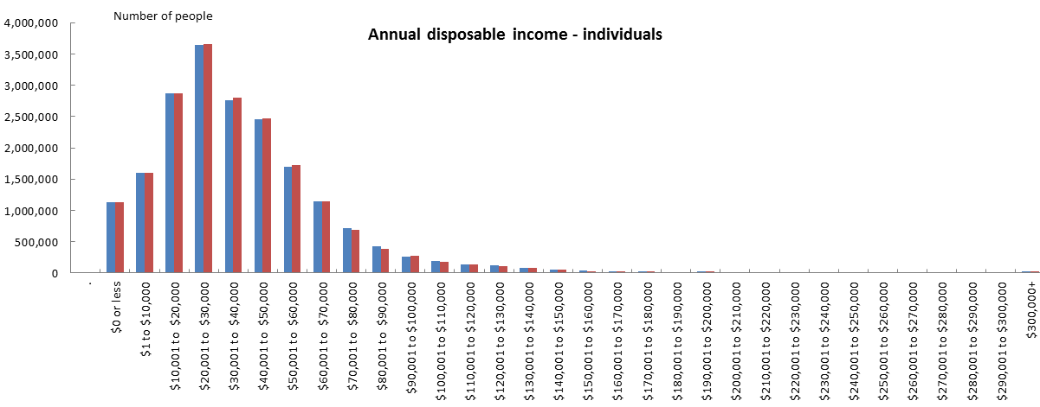 **Figure 2.2: Example of Disposable Income distribution before and after a policy change (blue and red, respectively).**

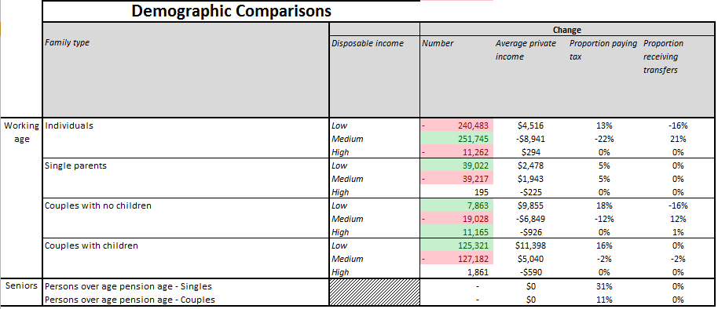

**Figure 2.3: Example demographic comparison table, showing impacts by family type.**



**Figure 2.4: Example payment summary output table produced by CAPITA.**

The Standard Output code can also be amended to produce other distributional analysis as required. Alternatively, the user can interrogate the output dataset to perform their analysis.

### *Cameo Analysis*

CAPITA contains the functionality to generate cameos. Cameo output contains the taxes and transfer payments applicable to particular, user-specified families. The following is an example of a cameo which was produced as part of the 2015-16 Budget[9].

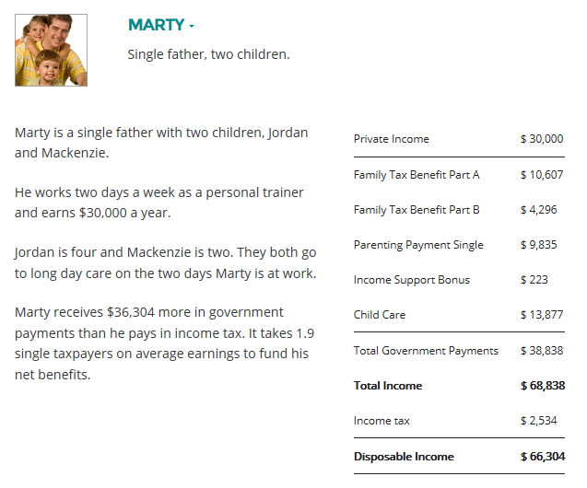

**Figure 2.5: Example cameo produced by CAPITA.**

1. Comparative Analysis of Personal Income Tax and Transfers in Australia.
2. This is in contrast to dynamic microsimulation models which simulate changes in the characteristics of each individual each year based on their characteristics in previous periods.
3. ABS 6553.0 –Survey of Income and Housing, User Guide, Australia 2017-18.
4. Wife pension ceased from 20 March 2020. Recipients moved onto Carer Payment or JobSeeker Payment after this date.
5. Known as NewStart Allowance prior to 20 March 2020.
6. Widow Allowance ceases from 1 January 2022. Recipients moved onto Age Pension after this date.
7. Sickness Allowance ceased from 20 March 2020. Recipients moved onto JobSeeker Payment after this date.
8. Partner Allowance ceases from 1 January 2022. Recipients moved onto Age Pension after this date.
9. The full suite of cameos published with the 2015-16 Budget are available online at <http://www.budget.gov.au>.